2-3 Activity: Packet Tracer

Blake Merry
Southern New Hampshire University
CYB-210 Programming Language
Prof. Jamilah Telon
March 13, 2026

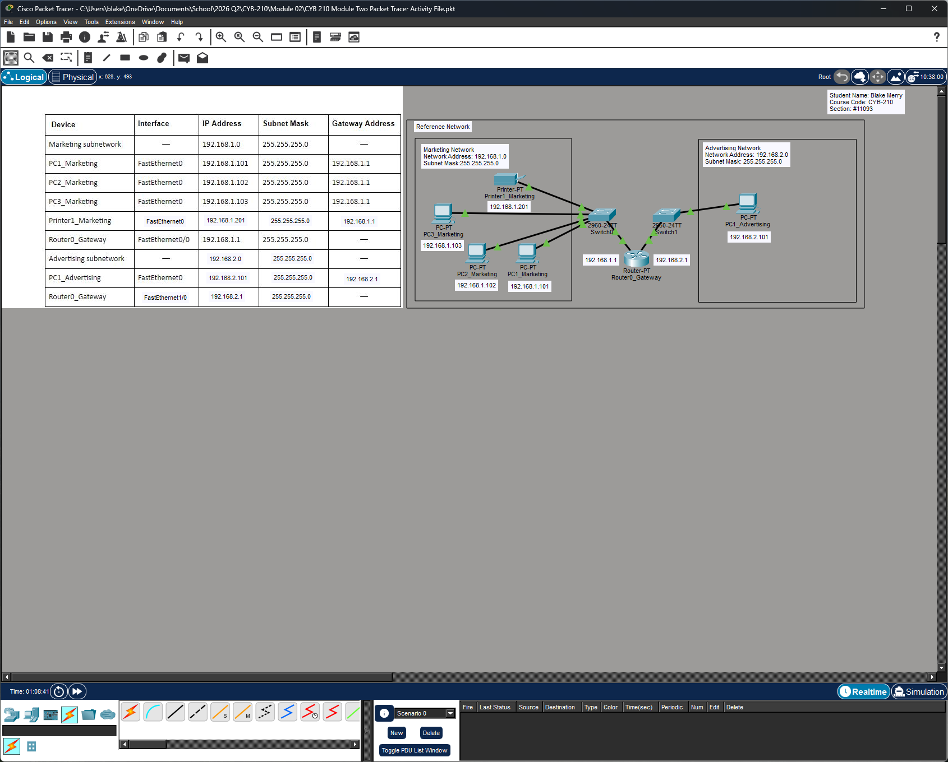
Network Diagram

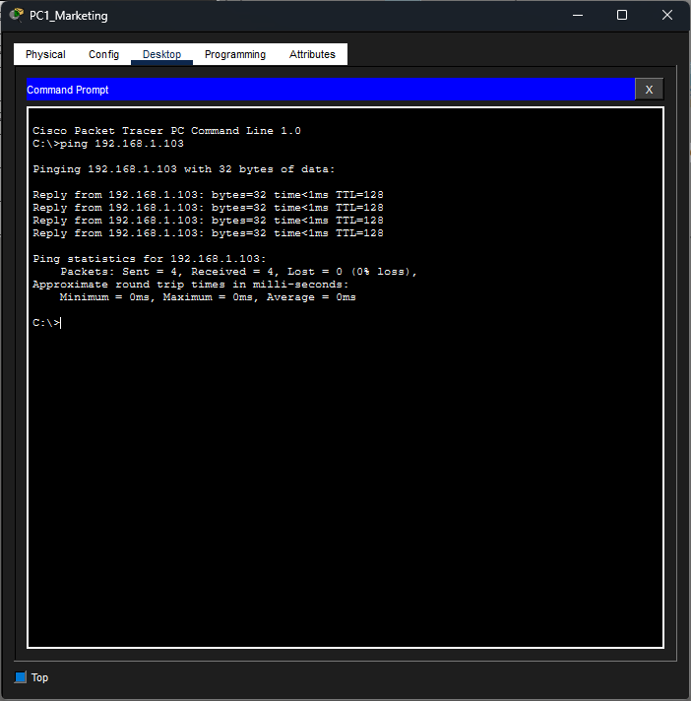
Ping PC1_Marketing to PC3_Marketing
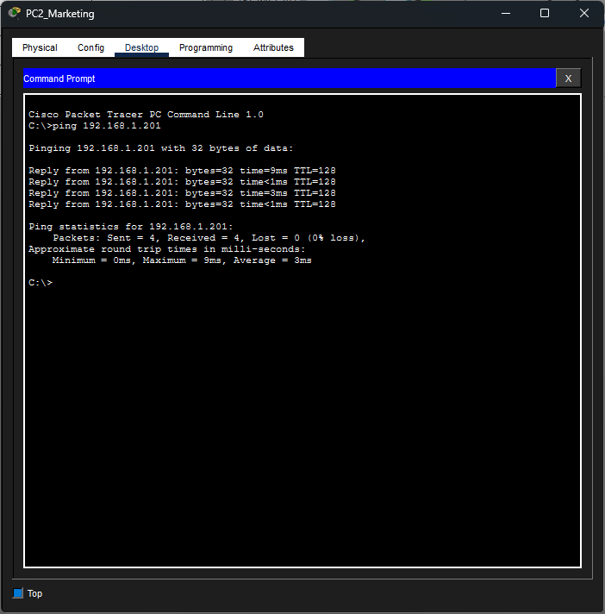
Ping PC2_Marketing to Printer1_Marketing
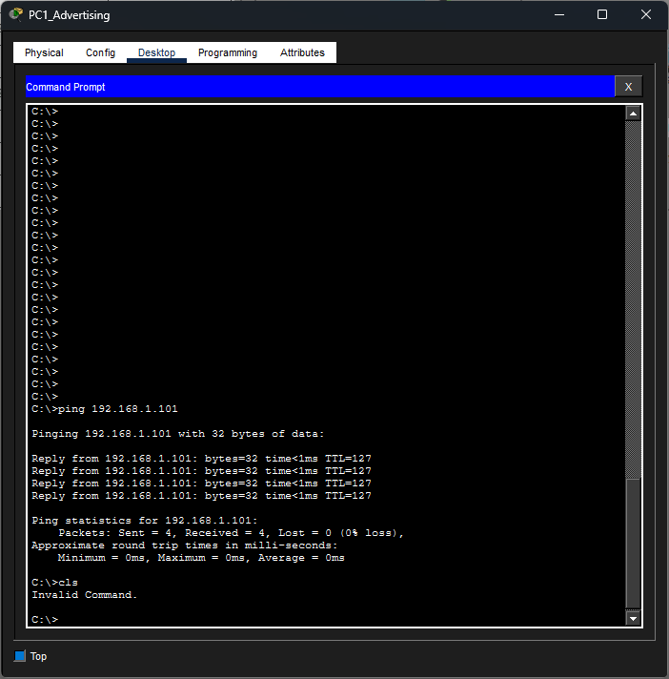
Ping PC1_Advertising to PC1_Marketing

